Hanmi R&D Aims to Close the Treatment Gap in Melanoma as Belvarafenib Advances Through Phase 2 Trial

Hanmi Presents Phase 2 Trial Design and Clinical Development Progress of Belvarafenib at Korean Cancer Association Annual Meeting
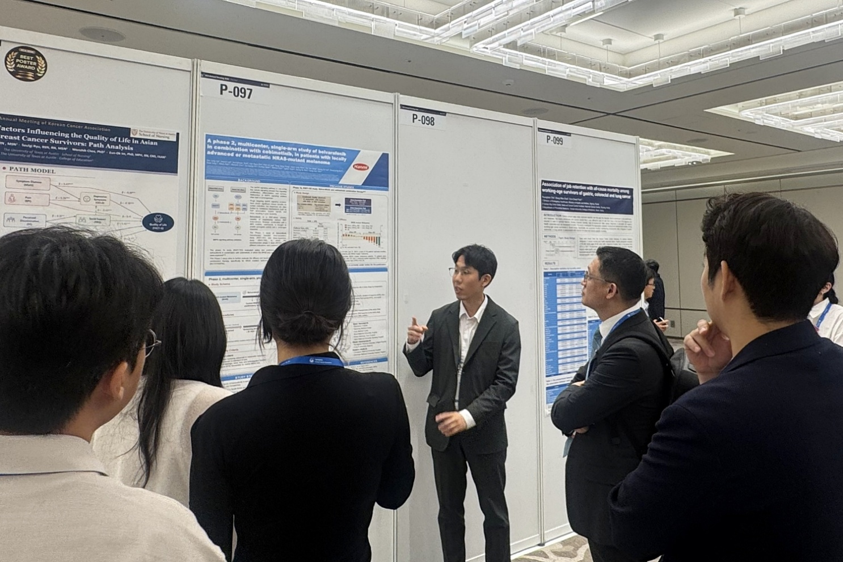
Meaningful antitumor efficacy demonstrated in patients with NRAS-mutant melanoma, for which no approved therapies exist in Korea or globally
Seongjung Kim, Researcher in Hanmi’s Clinical Development Team (center), presents a poster on the Phase 2 clinical development program of the oral targeted anticancer agent Belvarafenib to attendees at the 52nd Korean Cancer Association Annual Meeting (KCA 2026) on June 26.

(July 10, 2026) Hanmi is advancing Korea's first domestic Phase 2 clinical trial of Belvarafenib, a novel oral targeted anticancer therapy for melanoma, a malignant skin cancer.

Patient enrollment is currently underway for individuals who meet the trial eligibility criteria. If successfully commercialized, Belvarafenib is expected to offer a new treatment option for patients with NRAS-mutant melanoma who currently have limited treatment options.
Hanmi Pharmaceutical, a core operating company of Hanmi Science, announced on July 10 that it presented the Phase 2 trial design and development progress of Belvarafenib in a poster session at the 52nd Korean Cancer Association Annual Meeting (KCA 2026), held from June 25 to 26 at Grand InterContinental Seoul Parnas in Gangnam, Seoul.
Originally developed by Hanmi, Belvarafenib is an oral targeted anticancer agent designed to inhibit RAF and RAS gene mutations within the MAPK pathway, which is involved in tumor cell growth and proliferation.
Melanoma is a difficult-to-treat cancer characterized by limited treatment options and a high risk of recurrence, with most currently available therapies supplied by foreign pharmaceutical companies. In particular, NRAS-mutant melanoma has been reported to exhibit greater tumor invasiveness and metastatic potential than melanoma in general, as well as shorter overall survival.
In a global Phase 1 clinical trial conducted in patients with solid tumors, Belvarafenib demonstrated meaningful antitumor activity in patients harboring NRAS and BRAF mutations. Based on these findings, further clinical development is currently underway in Korea for patients with NRAS-mutant melanoma.
NRAS-mutant melanoma remains an area of high unmet medical need, with no approved standard-of-care therapies available worldwide. In current clinical practice, Belvarafenib is being administered on a limited basis to certain patients under treatment-purpose use approval (compassionate use).
The ongoing domestic Phase 2 trial is being conducted as a multicenter, single-arm study to evaluate the efficacy and safety of a combination therapy consisting of Belvarafenib and cobimetinib, a MEK inhibitor, in patients with locally advanced or metastatic melanoma harboring NRAS mutations.
The combination therapy of Belvarafenib and cobimetinib is regarded as a treatment strategy capable of overcoming the mechanistic limitations of existing BRAF inhibitor–MEK inhibitor combination therapies while offering the potential for sustained clinical benefit across a broader range of genetically defined patient populations.
Since enrollment of the first patient in February, the Phase 2 trial has been progressing smoothly across 10 clinical sites nationwide, with additional eligible patients continuing to be enrolled. Hanmi plans to complete enrollment of a total of 45 patients by 2027 and, based on the Phase 2 results, file for conditional approval in Korea in 2028.
Belvarafenib was selected for the the MFDS "Giljabi (Navigator)" program, an innovative product commercialization support initiative introduced last year to accelerate the development of promising innovative drug candidates with high social urgency and commercialization potential. The program provides systematic support for rapid commercialization, including assistance in preparing regulatory submissions linked to the GIFT expedited review program and advance reviews of documentation standards when necessary.
Moon Hee Lee, Head of Clinical Team at Hanmi, said, “Through the Phase 2 trial of Belvarafenib, we are focused on systematically evaluating efficacy and safety in patients with NRAS-mutant melanoma and we hope this clinical trial will offer a new treatment opportunity.” She added, “As patient enrollment continues, we hope this clinical trial will provide a new treatment opportunity for patients whose treatment options remain limited.”
■ Contact info:
Hanmi Pharm. Co., Ltd. (www.hanmipharm.com)
innovation@hanmi.co.kr, +82-02-410-0467

