Hanmi Pharmaceutical Partners with Organon to Export Combination Therapies to Southeast Asia

Cardiovascular and Respiratory medicines to be supplied in Malaysia and the Philippines
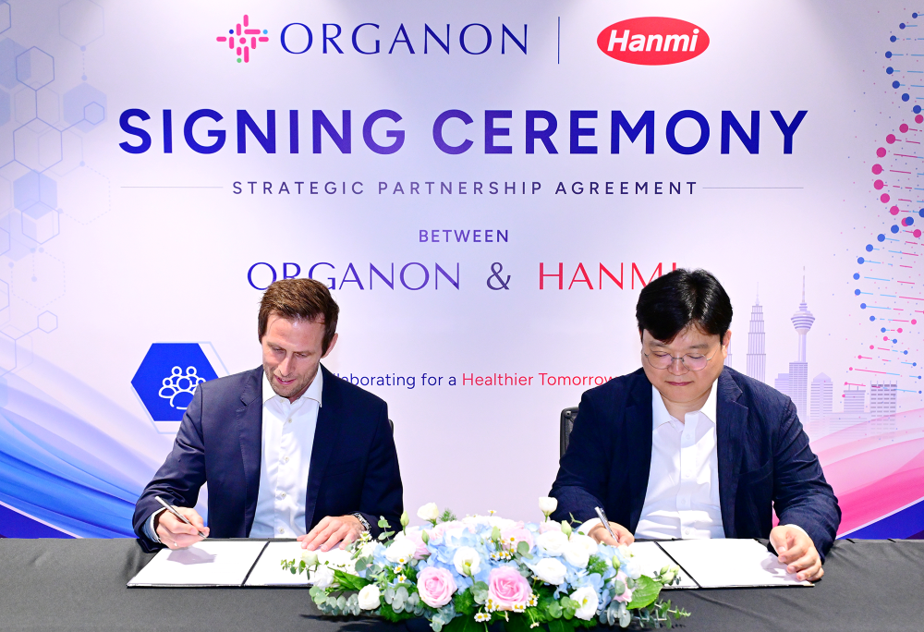
Shin Hae-gon (right), Head of Overseas Sales at Hanmi Pharmaceutical, and Andreas Daugaard Jørgensen (left), Managing Director, Organon Asia Pacific Cluster, met at Organon’s Malaysia office to discuss the expansion of Hanmi’s combination therapies into the Southeast Asian market.

(May 21, 2026)
Hanmi Pharmaceutical announced that it has signed a supply agreement with global healthcare company Organon to export three combination medicines for the Malaysian and Philippine markets, expanding the companies’ partnership in Southeast Asia.

Under the agreement, Hanmi will supply three finished combination products in the cardiovascular and respiratory therapeutic areas, while Organon will be responsible for marketing, distribution, and sales in the local markets. The two companies plan to pursue phased regulatory approvals and product launches in Malaysia and the Philippines, with the potential to expand their collaboration over the mid to long term.

Organon, established in 2021 is a global healthcare company with a portfolio of over 70 products across a range of therapeutic areas. Through a deep commercial ability and trusted manufacturing network, Organon brings these important medicines and devices to patients when and where they need them in over 140 markets, including Southeast Asia.

Hanmi Pharmaceutical has previously expanded its global presence through partnerships with multinational pharmaceutical companies. The current agreement with Organon builds on Hanmi’s experience in global collaborations and is expected to support the company’s commercial expansion in the Southeast Asian market.

Southeast Asia is widely regarded as a rapidly growing pharmaceutical market driven by population growth and the increasing prevalence of chronic diseases. In particular, demand for combination therapies is rising as the number of patients with chronic conditions such as hypertension continues to increase.

“At Organon, we are committed to improving access to medicines that address the greatest health needs in the communities we serve,” said Mazen Altaruti, President, Organon Emerging Markets. “This partnership with Hanmi reflects our shared focus on expanding treatment options for patients in Malaysia and the Philippines and advancing more equitable access to care across the region.”

Sean Hwang, CEO of Hanmi Pharmaceutical, said, “Hanmi will continue accelerating its global expansion with our diverse portfolio of combination therapies, which represent one of the company’s core strengths. Through our collaboration with Organon, we aim to improve treatment accessibility for patients in Southeast Asia.”
■ Contact info:
Official Websites: www.hanmipharm.com, www.linkedin.com/company/hanmipharm
innovation@hanmi.co.kr, +82-02-410-0467

