Hanmi’s Bispecific Cancer Immunotherapy Demonstrates Early Safety and Efficacy in Global Clinical Trials
< BH3120 Applying Next-Gen Bispecific Antibody Platform ‘Pentambody’>

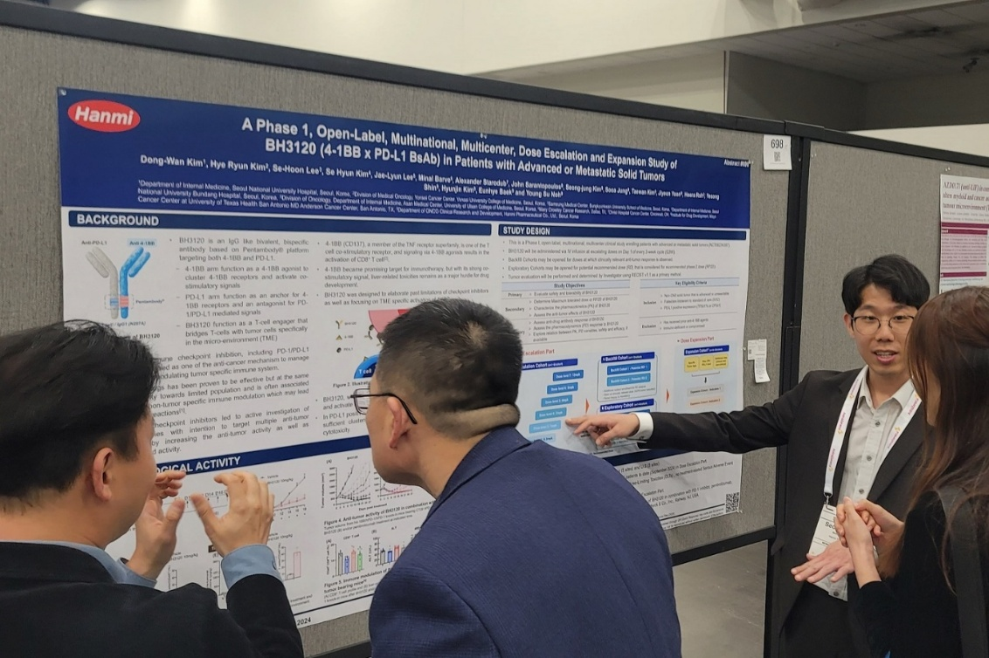
Hanmi Presents Phase 1 Clinical Study of BH3120 at ‘ESMO IO 2025’ in London, UK
Administered in Combination with MSD’s (Merck & Co., Inc., Rahway, NJ, USA) anti-PD-1 therapy, KEYTRUDA® (pembrolizumab)
Seongjung Kim, Researcher of Hanmi Pharmaceutical ONCO Clinical Team, presented a poster detailing the clinical progress of next-generation cancer immunotherapy BH3120 at the ESMO Immuno-Oncology Congress 2025 held in London, UK, on December 11 (local time).

(January 13, 2026) — Hanmi Pharmaceutical and Beijing Hanmi Pharmaceutical have jointly developed the next-generation cancer immunotherapy candidate ‘BH3120,’ which has confirmed early efficacy and a favorable safety profile in Phase 1 clinical trial, both as monotherapy and in combination with MSD’s (Merck & Co., Inc., Rahway, NJ, USA) anti-PD-1 therapy, KEYTRUDA® (pembrolizumab), demonstrating its therapeutic potential.

On January 13, Hanmi announced that it presented the research and clinical progress of its next-generation caner immunotherapy, BH3120 in a poster session at the ESMO Immuno-Oncology Congress 2025 (ESMO IO 2025), held in London, UK, from December 10 to 12 (local time).

BH3120 is a novel anticancer therapy developed using Hanmi’s proprietary bispecific antibody platform, "Pentambody." which enables a single antibody to bind simultaneously to two distinct targets. This mechanism allows for precise targeting of cancer cells while activating immune cells to enhance the efficacy of immunotherapy.

Specifically, BH3120 is designed to target PD-L1 on cancer cells and 4-1BB on immune cells, functioning as a molecular “bridge” that facilitates immune cell recognition and destruction of cancer cells.

While existing 4-1BB-targeting antibody candidates have shown limitations in anticancer efficacy or safety, BH3120 has demonstrated not only robust anticancer activity in multiple preclinical studies but also a distinct decoupling of immune activation between the tumor microenvironment (TME) and normal tissues. This unique feature underscores BH3120’s potential to deliver effective and safer anticancer therapy.

In April 2025, at the American Association for Cancer Research (AACR 2025), Hanmi presented results from extensive nonclinical studies aimed at further elucidating BH3120’s in vivo mechanism of action. These included an assessment of hepatotoxicity risk using a highly sensitive liver toxicity model and transcriptomic analyses evaluating BH3120’s impact on the immune environment within spheroid models. Both studies are expected to provide valuable insights for interpreting ongoing clinical trial results and shaping future development strategies.

Currently, a global Phase 1 trial is underway in South Korea and the United States, evaluating the safety and tolerability of BH3120 as monotherapy and in combination with KEYTRUDA® (pembrolizumab) in patients with advanced or metastatic solid tumors who have failed standard treatments, including prior immuno-oncology therapies.

At the congress, Hanmi shared comprehensive details on BH3120’s clinical research background, trial design, and current status. Dose-escalation is progressing smoothly in both monotherapy and combination arms, with no dose-limiting toxicities (DLTs) observed to date, confirming a favorable safety profile. Additionally, early signs of antitumor activity have been noted in certain patients who previously failed standard therapies, reinforcing BH3120’s therapeutic potential.

Young Su Noh, Director of Hanmi’s ONCO Clinical Team, stated, “The BH3120 clinical trial holds strategic significance as Hanmi’s first global study utilizing our proprietary bispecific antibody platform, ‘Pentambody,’ amid growing global interest in bispecific immuno-oncology therapies.” He continued, “We remain committed to advancing a next-generation immuno-oncology therapy that not only overcomes the limitations of existing treatments but also delivers enhances efficacy with a favorable safety profile.”

Meanwhile, Hanmi entered into a Clinical Trial Collaboration and Supply Agreement (CTCSA) with MSD in April last year to conduct combination trial of BH3120. In September, the U.S. Food and Drug Administration (FDA) and Korea’s Ministry of Food and Drug Safety (MFDS) approved the Investigational New Drug (IND) application for the combination trial. Under this agreement, Hanmi serves as the sponsor overseeing the clinical trial, while MSD supplies KEYTRUDA® (pembrolizumab) for use in the trial.

KEYTRUDA® is a registered trademark of Merck Sharp & Dohme Corp., a subsidiary of Merck & Co., Inc., Rahway, NJ, USA.

<The End>
■ Contact info:
Official Websites: www.hanmipharm.com
innovation@hanmi.co.kr, +08-2-410-0467

