Hanmi Accelerates Global Expansion Through Strategic Collaboration with Tabuk Pharmaceuticals for its Innovative Biologic Product, Rolontis (Eflapegrastim), in the Middle East–North Africa (MENA) Region

Hanmi signs an Exclusive License and Supply Agreement with Saudi Arabia’s Tabuk for Rolontis
Building on U.S. success, Hanmi accelerates expansion of innovative therapies across the MENA region
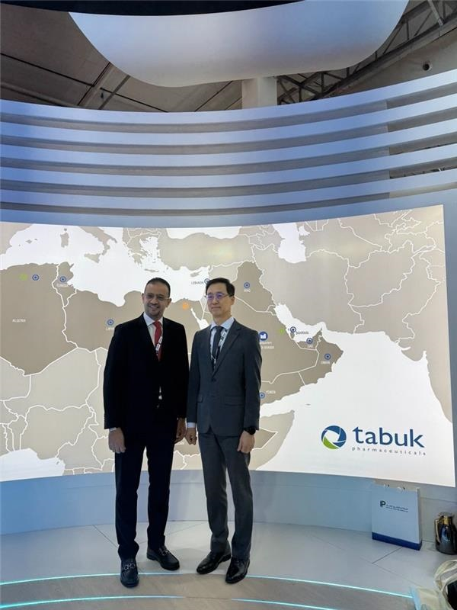
(Seoul, September OO, 2025) Hanmi Pharmaceutical has taken a significant step toward entering the MENA market with its innovative biologic product Rolontis for the treatment of chemotherapy-induced neutropenia.

Hanmi announced that it recently signed an Exclusive License and Supply Agreement with Tabuk Pharmaceuticals, a leading Saudi pharmaceutical company in Saudi Arabia and the MENA region. Building on this momentum, Hanmi and Tabuk plan to work closely to ensure the successful entry of Rolontis into the region.

As part of this effort, Hanmi CEO Jae-Hyun Park met with Tabuk CEO Ismail Shehada and Chief Business Officer Wisam Al Khatib to discuss strategies and further solidify the partnership.

With proven commercial capabilities and a strong presence across the Middle East and Africa, Tabuk Pharmaceuticals is a trusted partner positioned to ensure the successful launch and long-term growth of Rolontis. Through this collaboration, both companies aim to expand patient access to an innovative supportive care therapy and address a critical unmet need in oncology treatment across the region.
<Photo> Hanmi CEO Jae-Hyun Park and Tabuk CEO Ismail Shehada discussed strategies to introduce Hanmi’s innovative therapies, including Rolontis, to the Middle Eastern market.

The Middle East and North Africa (MENA) region, encompassing a population of nearly 600 million, offers considerable potential for pharmaceutical market expansion. Within this landscape, the Kingdom of Saudi Arabia is emerging as a strategic hub, supported by high per capita income and a rapidly evolving healthcare infrastructure. Tabuk Pharmaceuticals, recognized as one of the leading pharmaceutical manufacturers in the region, maintains an established commercial presence in 17 MENA countries, enabling broad access to therapeutics and contributing to regional public health advancement.

Rolontis, developed in-house by Hanmi Pharmaceutical, is the first biologic drug originating from a Korean pharmaceutical company to receive U.S. FDA approval for the treatment of chemotherapy-induced neutropenia. Since its U.S. launch in 2022 under the brand name Rolvedon, the drug has continued to demonstrate strong global competitiveness, driven by its established efficacy and safety. Quarterly U.S. sales have consistently exceeded USD 10 million. As of 2024, cumulative sales in the U.S. have surpassed USD 154 million, while domestic sales in Q2 recorded a 26% year-over-year increase.

Furthermore, the two companies plan to continue their collaboration not only for the License and Supply Agreement of Rolontis but also for the entry of various specialty medicines from Hanmi Pharmaceutical into the Middle East and North Africa market, including the combination therapy for Benign Prostatic Hyperplasia, Gugutams.

“Our partnership with Hanmi reflects a shared commitment to advancing healthcare and delivering meaningful innovation to patients in Saudi Arabia and the Middle East,” said Ismail Shehada, CEO of Tabuk Pharmaceuticals. “By combining Hanmi’s proven scientific excellence with Tabuk’s regional expertise and patient-focused vision, we are proud to introduce Rolontis—a breakthrough biologic that not only elevates standards of care but also supports patients with better access to innovative therapies that can transform health outcomes.”

Jae-hyun Park, CEO of Hanmi Pharmaceutical, added, “This partnership marks a strategic foundation for unlocking new growth in the emerging MENA pharmaceutical market. Through our collaboration with Tabuk, we aim to realize Hanmi’s global vision and establish a strong brand presence across MENA.”

<The End>

■ Contact info:
Tabuk Pharmaceuticals (www.tabukpharmaceuticals.com):
bd@tabukpharmaceuticals.com
Hanmi Pharmaceutical (www.hanmipharm.com)
innovation@hanmi.co.kr, +82-02-410-0467

