"Pushing the Boundaries of GLP-1 Innovation" — Hanmi to Present Six Obesity Drug Studies at ADA 2025
Hanmi Pharmaceutical to Unveil Six Research Updates on HM15275 and HM17321 at ADA 2025
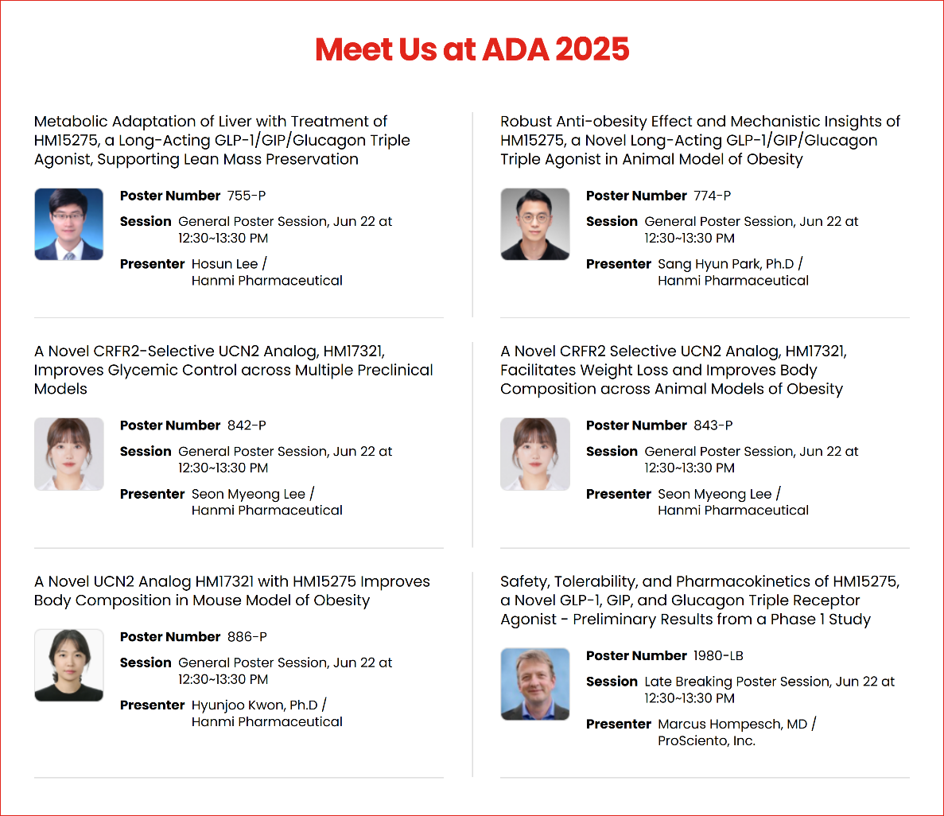
Phase 1 Results of Next-Generation Triple Agonist HM15275 to Be Unveiled for the First Time; Phase 2 Initiation Targeted for Second Half of 2025
<Photo> Overview of key poster abstracts Hanmi will present at ADA 2025 (Source: Hanmi Pharmaceutical homepage)

(June 10, 2025) Hanmi Pharmaceutical is set to unveil a series of breakthrough research results on its next-generation, game-changing obesity drug candidates that overcome the inherent limitations of GLP-1-based therapies, including inevitable muscle loss, at one of the world’s most prestigious metabolic disease conferences.

Hanmi will participate in the American Diabetes Association (ADA) 2025 annual meeting, to be held June 20–23 in Chicago, U.S., where it will present six studies on its next-generation obesity treatments: the triple agonist (LA-GLP/GIP/GCG, HM15275) and the novel obesity drug (LA-UCN2, HM17321).

This presentation will serve as a key opportunity for Hanmi to showcase the competitiveness of its core pipelines under the ‘H.O.P (Hanmi Obesity Pipeline) Project’ to the global market.

The company is accelerating the development of innovative treatments under this project, aiming to provide personalized solutions across the full spectrum of obesity management. Hanmi has drawn particular attention for its differentiated candidates that address the diverse characteristics and treatment needs of broad obesity patient populations, overcoming many of the shortcomings of current therapies.

HM15275 and HM17321, both scheduled for presentation at ADA 2025, represent next-generation pipelines following the innovation of efpeglenatide, which is targeted for commercialization in the second half of 2026. Each has demonstrated the potential to emerge as either a ‘Best-in-Class’ or ‘First-in-Class’ treatment in the obesity field.

The ADA 2025 presentations will cover: Phase 1 Trial Results for HM15275, ▲Robust anti-obesity effect and mechanistic insights of HM15275 in animal models of obesity, ▲Mechanistic insights into HM15275’s improved quality of weight loss compared to tirzepatide (Zepbound), ▲Weight loss and differentiated body composition improvement effects of HM17321, ▲Glycemic control improvement observed with HM17321, and ▲Synergistic effects on body composition improvement when combining HM15275 and HM17321

A large delegation from Hanmi’s R&D Center will attend ADA 2025 to present poster sessions showcasing the company’s novel therapeutic approaches in obesity treatment and to explore potential collaborations with leading global pharmaceutical companies.

◆ HM15275: Next-Generation Triple Agonist Targeting Quantity and Quality of Weight Loss

HM15275 is engineered to optimize the activity balance of GLP-1, GIP, and glucagon (GCG) receptors, delivering targeted obesity treatment while also addressing comorbid metabolic conditions such as diabetes, cardiovascular, and renal disease. The drug has demonstrated the potential to deliver more than 25% total body weight loss—comparable to bariatric surgery—while minimizing lean mass loss, making it a highly promising option for improved weight loss quantity and quality.

Preclinical data presented at ADA 2024 showed that HM15275 delivered superior weight loss efficacy compared to semaglutide (Wegovy) and tirzepatide (Zepbound), with relatively less reductions in lean mass. Hanmi will present Phase 1 results for HM15275 for the first time at ADA 2025. This Phase 1 trial, completed on an accelerated timeline, marks a key milestone in validating both the safety and translational potential of Hanmi’s next generation triple agonist in humans.

Based on these results, Hanmi plans to initiate Phase 2 clinical trials in the second half of 2025, evaluating the long-term effects of HM15275 in reducing body weight and preserving lean mass in patients with severe obesity. If successful, HM15275 is positioned to emerge as a best-in-class triple agonist that could redefine the standard of care for patients with limited options under existing GLP-1-based therapies.

◆ HM17321: World’s First UCN2-Based ‘Muscle-Building’ Obesity Therapy

HM17321 is a novel UCN2 (urocortin 2) analog that selectively targets the corticotropin-releasing factor 2 (CRF2) receptor, distinct from incretin-based therapies, while uniquely designed to reduce fat mass and simultaneously increase muscle mass.

Leveraging Hanmi’s proprietary AI-driven structural modeling platform, HM17321 delivers significantly enhanced target selectivity and precision, offering a potentially transformative approach that enables simultaneous weight loss and muscle gain, long considered physiologically incompatible.

Preclinical data presented at Obesity Week 2024 demonstrated that HM17321 achieved weight loss efficacy comparable to semaglutide (Wegovy), while uniquely increasing both lean mass and muscle mass.

At ADA 2025, Hanmi will present new findings exploring whether muscle hypertrophic effects also translate into broader metabolic improvements, such as enhanced glycemic control and increased basal metabolic rate. These data are expected to further validate HM17321’s potential as a first-in-class treatment offering a fundamentally differentiated mechanism of action from current GLP-1 therapies.

Beyond its monotherapy potential, HM17321 has also demonstrated additive efficacy when used in combination with incretin-based agents, further expanding its versatility as a next-generation obesity solution. Hanmi expects to initiate Phase 1 clinical trials for HM17321 in the second half of 2025.

According to recent reports from GlobalData Patent Analytics and IFI CLAIMS Patent Services, Hanmi ranks among the global leaders in both the volume and quality of obesity drug patent filings, alongside multinational pharmaceutical companies such as Eli Lilly and Novo Nordisk.

“Innovation in metabolic and endocrine diseases has been a core focus for Hanmi over many years, and the ADA 2025 presentations represent a critical opportunity to showcase our global competitiveness,” said Dr. In Young Choi, Head of Hanmi R&D Center. “Through differentiated development strategies and novel mechanisms that address unmet needs in obesity treatment, Hanmi is committed to becoming a global leader in obesity innovation. We are fully dedicated to expediting the clinical development and commercialization of these groundbreaking therapies.”

<The End>

■ Contact info:
〮Official Websites: www.hanmipharm.com
innovation@hanmi.co.kr, +82-2-410-0467

