Hanmi Discovers a Key Biomarker for its Best-in-Class EZH1/2 Dual Inhibitor HM97662, Paving the Way for Clinical Success

Poster Presentation of HM97662 Preclinical Data at the Bio-IT World 2025, April 2–4
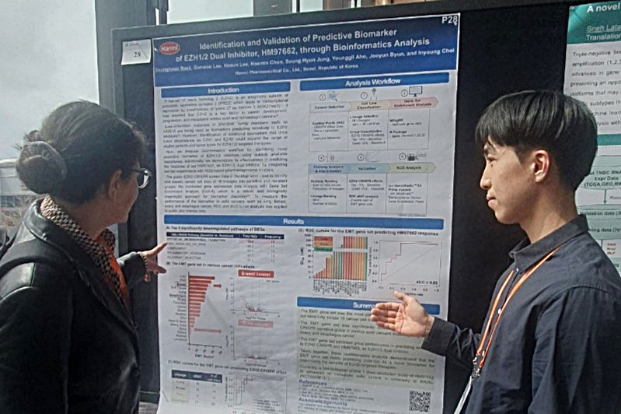
Hanmi’s Gene Expression-Based Biomarker Predicts Strong Anti-tumor Activity Across Various Solid Cancers
Hanmi Tops Korea in AACR Presentations for 3rd Straight Years, Underscoring Oncology Leadership
Hanmi Pharmaceutical researcher Seungheon Baek (right) explained key findings of the company’s next-generation anti-cancer candidate, “EZH1/2 dual inhibitor HM97662”, to attendees at the Bio-IT World Conference & Expo, held on April 2-4, 2025 (local time).

Hanmi Pharmaceutical has identified a novel biomarker that supports the development of its next-generation anti-cancer therapy, the EZH1/2 dual inhibitor HM97662, paving the way for more personalized cancer treatment and improved clinical response.

The company announced on April 7 that it presented a poster outlining preclinical findings of HM97662 at the 24th Bio-IT World Conference & Expo, held on April 2–4, 2025 in Boston, USA (local time).

EZH1 and EZH2 proteins—often referred to as “key epigenetic regulators”—play critical roles in the development, progression and differentiation of malignant tumors. By simultaneously blocking both proteins, HM97662 shows potent anti-tumor effects through upregulation of tumor-suppressor genes related to cell cycle and proliferation.

HM97662 targets both EZH1 and EZH2 to enhance efficacy and overcome resistance caused by EZH2-selecitve inhibitors. Based on outstanding anti-tumor efficacy demonstrated in preclinical studies, a global Phase 1 clinical trial is currently underway in South Korea and Australia, evaluating the safety and tolerability of HM97662 as a monotherapy in patients with advanced or metastatic solid tumors.

At this year’s conference, Hanmi highlighted the potential of biomarker discovery through bioinformatic analysis to guide patient selection and predict drug response during the development of Hanmi’s EZH1/2 dual inhibitor.

Until now, loss-of-function mutations in SWI/SNF family members have suggested as biomarkers predicting sensitivity to EZH1/2 inhibitors. However, due to their limited predictive power, the need for alternative biomarker has emerged.

To address this, Hanmi demonstrated bioinformatics workflows utilizing the DepMap (Dependency Map) public database to identify gene expression-based biomarker capable of predicting anti-tumor response to EZH1/2 dual inhibition. The biomarker showed robust performance for the prediction of sensitivity to HM97662, particularly in several cancer types including lung, ovarian, and esophageal cancers.

A Hanmi official commented, “HM97662 is a next-generation and best-in-class EZH1/2 inhibitor that is applicable to patients with specific genetic mutations and gene expression-based biomarkers.” The company added, “Through continued research, we aim to establish a robust foundation for developing personalized treatment strategies with HM97662.”

Meanwhile, Hanmi is set to present 11 research abstracts—including data on HM97662—covering seven pipeline assets at the upcoming AACR Annual Meeting 2025. For the recent three years, Hanmi has been conducting anti-cancer research with greater passion than any other Korean pharmaceuticals or biotech company, underscoring meaningful progress in its oncology R&D pipeline.

Dr. In Young Choi, Head of Hanmi’s R&D Center, stated, “Oncology remains a core pillar of Hanmi’s drug development strategy. Backed by years of accumulated R&D capabilities, our pipeline now spans diverse modalities, including mRNA, cell and gene therapies (CGT), targeted protein degradation (TPD), antibody-drug conjugates (ADC), and single-domain antibodies (sdAb).” He added, “We expect this year’s AACR presentations to serve as a major ignition point for global recognition of Hanmi’s expanding innovation capacity.”

<The End>
■ Contact info:
〮Official Websites: www.hanmipharm.com
innovation@hanmi.co.kr, +08-2-410-0467

