**Hanmi Enters into Clinical Trial Collaboration and Supply Agreement with MSD to Evaluate BH3120 in Combination with KEYTRUDA® (pembrolizumab)**

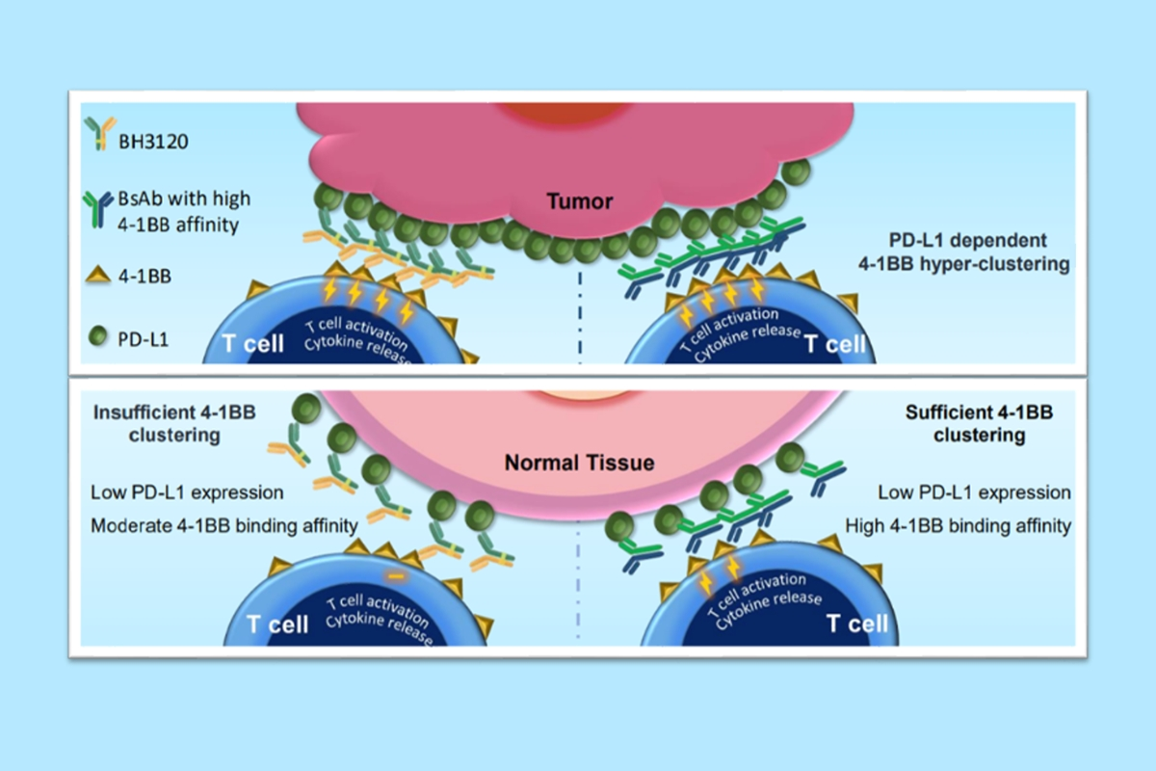**Hanmi Pharmaceutical announces Clinical Trial Collaboration with MSD to evaluate ‘BH3120’ in combination with KEYTRUDA in phase 1 clinical trial in patients with progressive or metastatic solid tumors**

**<Mechanism of action of BH3120 presented by BJHM(Beijing Hanmi Pharmaceutical) at AACR 2023>**

Hanmi Pharmaceutical (KOSPI: 128940, CEO: Jae-Hyun Park), a leading biopharma company in Korea that focuses on research areas such as oncology, obesity/metabolism, and rare diseases, announced it has entered into a Clinical Trial Collaboration and Supply Agreement (CTCSA) with MSD (a tradename of Merck & Co., Inc., Rahway, NJ, USA).

Upon the execution of the agreement, Hanmi Pharmaceutical will conduct a phase 1 clinical trial to evaluate the safety and efficacy of its immuno-oncology drug, ‘BH3120’, in combination with MSD’s anti-PD-1 therapy, KEYTRUDA® (pembrolizumab), in patients with progressive or metastatic solid tumors. Hanmi Pharmaceutical will sponsor the clinical trial, and MSD will supply KEYTRUDA.

'BH3120' is a next-generation immunotherapy drug that applies 'Pentambody', a bispecific antibody platform technology, currently under joint development by Hanmi Pharmaceutical and its Chinese subsidiary, BJHM (Beijing Hanmi Pharmaceutical).

Pentambody is a technology that combines one antibody to two different targets simultaneously, facilitating both immuno-oncology therapy and targeted therapy.

More specifically, BH3120 is an lgG-like bivalent bispecific antibody targeting PD-L1 and 4-1BB with biased binding affinities towards PD-L1.

This design aims to induce strong antitumor activities, particularly in PD-L1 overexpressed tumor tissues within the tumor microenvironment (TME), while minimizing undue immune activation in normal tissues.

Most of the existing antibody candidates targeting 4-1BB have limitations in terms of safety. However, BH3120 has been shown through various non-clinical studies to exhibit a clear decoupling of immune activity between TME and normal tissue, confirming its potential as an effective and safe anticancer agent.

Dr. Kim Dong-wan, the director of the Seoul National University Hospital Clinical Trials Center (Hemato-Oncology Department), is the Principal Investigator of the phase 1 clinical trial of BH3120 in Korea and US. He said, “Through the collaboration with MSD, we expect BH3120 in combination with KEYTRUDA could improve outcomes for patients with relapsed or refractory disease.”

A Hanmi representative stated, "BH3120 is our first global clinical research project using the next-generation bispecific antibody platform technology 'Pentambody' in the field of immuno-oncology therapy, potentially changing the paradigm of anticancer treatment," and added, “We are dedicated to surpassing the constraints of current therapies and innovatively boosting therapeutic efficacy through our next-generation immune-oncology therapy.”

KEYTRUDA® is a registered trademark of Merck Sharp & Dohme LLC, a subsidiary of Merck & Co., Inc., Rahway, NJ, USA.

**<The End>**

■ Contact info:

〮Official Websites: [www.hanmipharm.com](http://www.hanmipharm.com)

[innovation@hanmi.co.kr](mailto:innovation@hanmi.co.kr), +08-2-410-0467

▶ Introducing Hanmi Pharmaceutical

Established in 1973, Hanmi Pharmaceutical is an R&D-centric pharmaceutical company that strives to create global first in class drugs through industry-leading R&D investments. Hanmi Pharmaceutical has strategically established more than 30 pipelines covering metabolic diseases(diabetes, obesity), inflammation-fibrosis(MASH) treatment, anticancer drugs and rare disease treatments, among which 'Rolontis', a neutropenia treatment, has received marketing authorization from the FDA in 2022. The company retains solid partnerships with leading global pharmaceutical companies based on proprietary technologies such as ‘LAPSCOVERY’, a platform technology that prolongs the duration of action of biologics, and ‘PENTAMBODY’, a bispecific antibody platform technology. Hanmi Pharmaceutical is enhancing the synergy of various R&D activities, such as AI new drug development and immuno-anticancer drug development, through the ‘Open Innovation’ strategy that opens the door to excellent external R&D capabilities. For more information, please refer to our website <https://www.hanmipharm.com>

▶ About BH3120

BH3120 is a heterodimeric bispecific antibody (PENTAMBODY) designed to target 4-1BB and PD-L1 simultaneously to stimulate anti-tumor immune response either by inhibition of an immune checkpoint mechanism and by activation of a co-stimulatory signal in tumor microenvironment (TME) focused manner. Non-clinical observations with BH3120, either as a monotherapy or in combination settings, consistently explain strong anti-tumor T cell activities in tumor tissue-specific manner with clear dose dependency, while systemic immune response is minimally modulated. These properties support further evaluation of the immune-modulating bispecific antibody, and BH3120 will be studied as a therapeutic candidate with multiple types of solid tumors.